**DISCOUNTS**

**TO START,  
1.) Menu**

**2.) Maintenance  
3.) Discounts**

Discounts

Maintenance

Menu

3 1*1*

2 1*1*

1 1*1*

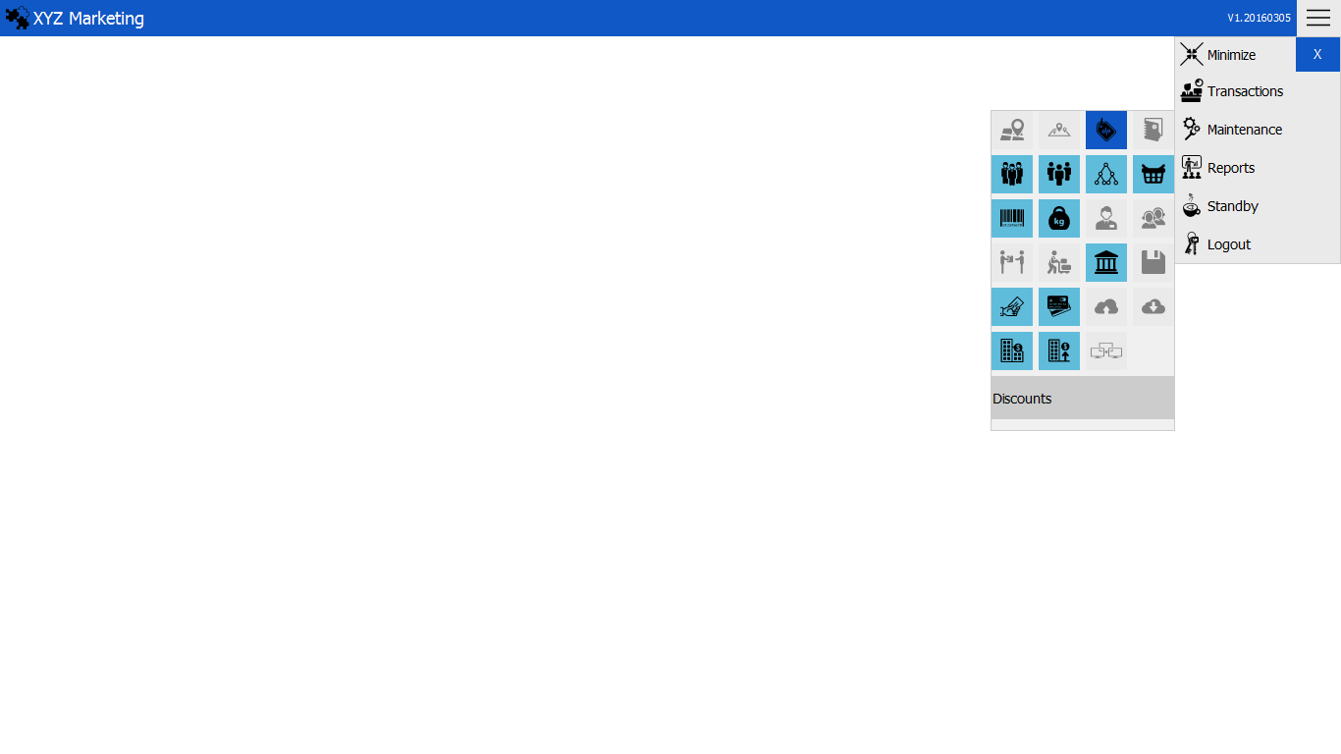

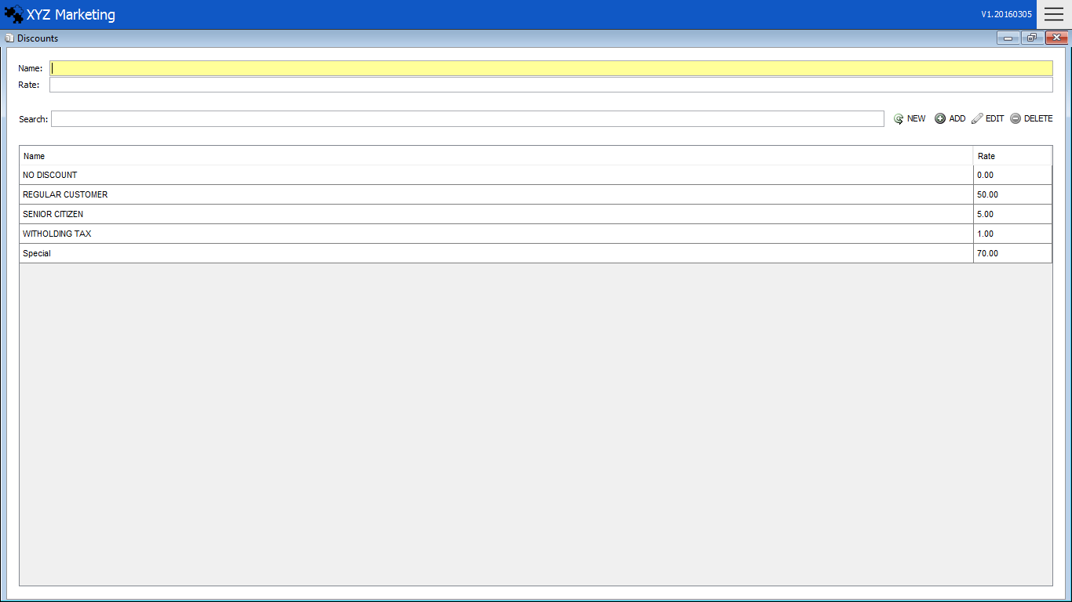 **NEW DISCOUNT  
 1. ) Input name of the discount  
 2. ) Input the rate of discount  
 3. ) Add**

Add

3 1*1*

Name

Rate of Discount

2 1*1*

1 1*1*

List

Search Box

1. **) Input name of the discount**

Input the name the discount want to add.

1. **) Input the discount rate**

Input the percentage of the discount rate.

1. **) Add, Update & Delete**

**3.1) Add**

Click the add button to finish.

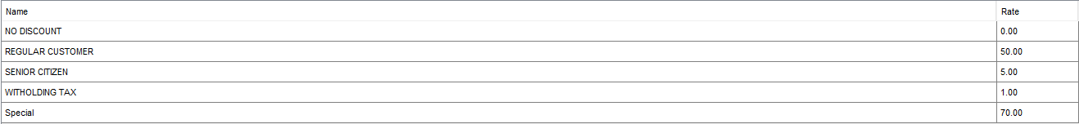**3.2) Update**



Click the discount name in the list wanted to update.

Click the update button after the changes made to finish.

**3.3) Delete**



Click the delete button to finish.

Click the discount name in the list wanted to delete.